Angel Perez

Juan Campista

ECE373

# **Use Case Diagram:**

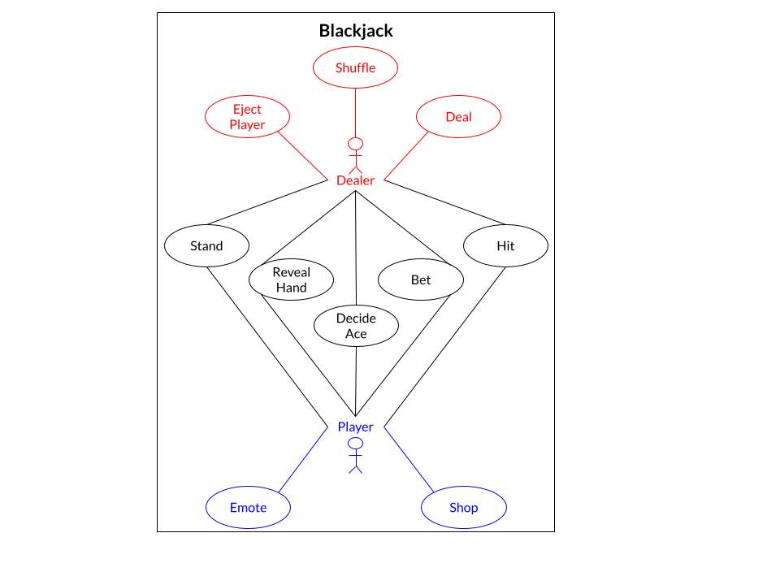

# **Use Case Descriptions:**

### **Use Case:** Bet

#### **Actors**:

* Player
* Dealer

#### **Preconditions:** The person must have enough funds to place a bet

#### **Description:** The person can place a bet anywhere between a minimum of $20 to a maximum of their current funds allows for

#### **Exceptions:**

* Insufficient funds results in the person being ejected from the game

### **Use Case:** Hit

#### **Actors**:

* Player
* Dealer

#### **Preconditions:** The person must be below or equal to 21

#### **Description:** The person receives a random card from the deck

#### **Exceptions:**

* The person’s current hand isn’t over 21 (a bust)

### **Use Case:** Stand

#### **Actors**:

* Player
* Dealer

#### **Preconditions:** The person must be below or equal to 21

#### **Description:** The person remains on standby, basically doing nothing

#### **Exceptions:**

* The person’s current hand isn’t over 21 (a bust)

### 

### **Use Case:** Reveal Hand

#### **Actors**:

* Player
* Dealer

#### **Preconditions:** The game is concluded

#### **Description:** The game is over, therefore everyone reveals their hand deciding who wins the game

#### **Exceptions:**

* The game isn’t over

### **Use Case:** Decide Ace

#### **Actors**:

* Player
* Dealer

#### **Preconditions:** The person must have an ace up their sleeve

#### **Description:** In Blackjack an ace can hold the value of 1 or 11, this is dependent on the current hand

#### **Exceptions:**

* The ace can’t be decided if their current hand exceeds 21, therefore forcing the ace to be 1.

### **Use Case:** Shop

#### **Actors**:

* Player

#### **Preconditions:** The player must be in the main menu

#### **Description:** In the shop the player can buy new emotes and cute hats to customize their experience more.

#### **Exceptions:**

* The player is broke and has no money to buy anything

### **Use Case:** Emote

#### **Actors**:

* Player

#### **Preconditions:** The player must be in game

#### **Description:** The player displays one of their many emotes to express their emotions

#### **Exceptions:**

* The player is in the main menu, in which they can’t emote

### **Use Case:** Shuffle

#### **Actors**:

* Dealer

#### **Preconditions:** The deck must not be already shuffled or there are no more cards left to play

#### **Description:** Randomizes the deck to level the playing experience

#### **Exceptions:**

* The deck doesn’t need to be shuffled

### **Use Case:** Deal

#### **Actors**:

* Dealer (Or House)

#### **Preconditions:** The person is requesting a hit or it is the beginning of the game

#### **Description:** A card is omitted from the deck and given to the person’s hand

#### **Exceptions:**

* The person’s current hand is over 21 (a bust)

### **Use Case:** Eject Player

#### **Actors**:

* Dealer (Or House)

#### **Preconditions:** The person must have no more remaining funds, thus making them ineligible to play

#### **Description:** Removes the player from the game entirely

#### **Exceptions:**

* They still have funds